City of Paramount

Goal Setting Report

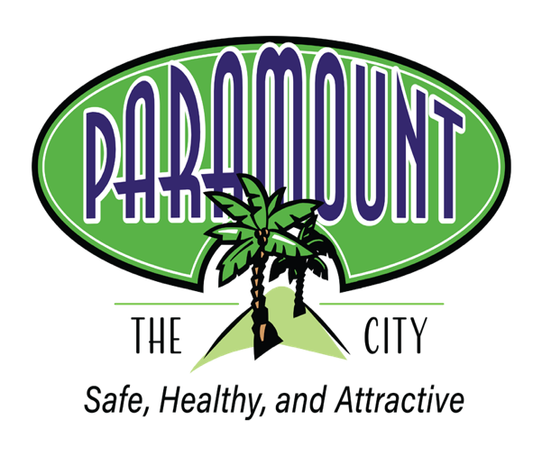

Report Assembled By:
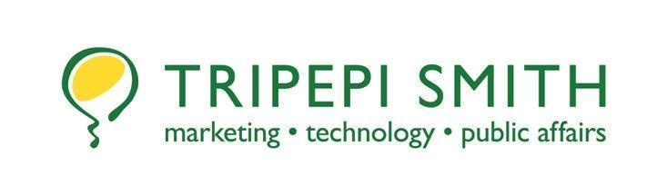

Authors:
Mike Egan, Director
Sofia Gonzalez, Junior Business Analyst

January 2026

Table of Contents

Table of Contents 1
Executive Summary 2
Essential Goals 3
Important Goals 5
Value-Added Goals 6
Paramount City Council Long-Term Goals 7
Safe Community 7
Community Health 7
Attractive, Well-Maintained Infrastructure 7
Invest in Staff Development 7
Enhanced Community Image 7
Efficient, Effective and Fiscal Responsibility 7
Improved Communications/Responsiveness 7
Exhibit A – January 29, 2026 Tripepi Smith PowerPoint Deck 8

Executive Summary

On January 27, 2026, Tripepi Smith facilitated a public goal-setting session with the Paramount City Council and members of the City’s executive team. The Council discussed a broad range of overall goals address the community’s most pressing needs, agreeing upon 11 essential goals, 7 important goals and 4 value-added goals. They focus on public safety, infrastructure projects and improved communications for the immediate future, while additional goals will be developed as staff capacity and revenues continue to grow. The report is based on the City Council's consensus around the goals and expanded objectives.
The Paramount City Council's long-term goals are strategic, community-centered and forward-looking. These goals are focused on addressing immediate priorities while laying the groundwork for long-term stability and growth. Together, they help ensure that Paramount remains a safe, responsive and thriving community for years to come.

Essential Goals
These goals address the City’s most urgent and high-priority needs, focusing on actions that have the greatest immediate impact on public safety, city operations and the core services.
Goal #1: Assess opportunities to expand staggered street sweeping schedules where appropriate and supported by affected residents
Goal #2: Enhance traffic safety signage near schools
Goal #3: Upgrade recognition certificates to with a refreshed logo, to start with the new Mayoral term
Goal #4: Promote a Care Solace bulletin on Channel 36
Goal #5: Improve timeliness of Council notifications with the Sheriff’s Department’s incident template
Goal #6: Enhance local workforce development programming through SELACO WDB partnership
Goal #7: Council decision regarding moving election date from June to November
Goal #8: Enhance social media programming with more video highlighting community services programming
Goal #9: Ensure Emergency vehicle access during Santa Train to the greatest extent possible
Goal #10: Update Best Practice to improve survey responses from residents on important matters
Goal #11: Work with Congressional Representative to support and keep residents informed of legal rights during federal immigration operations

Important Goals

These goals support strategic improvements and the City’s long-term priorities. While not as urgent as essential goals, they will help the City operate more effectively over time.
Goal #1: Social Media Education Program promoting E-Bike Safety
Goal #2: Press Caltrans to be more responsive and improve maintenance standards on graffiti and landscaping
Goal #3: Enhance Mental Health awareness programming for the community and particularly seniors
Goal #4: Develop social media campaign to include scam avoidance and money saving tips
Goal #5: Update sidewalk inspection schedule and address sidewalk displacements on Indiana between Monroe and Alondra
Goal #6: Address alley parking problems blocking waste and fire trucks, focusing on repeat offenders
Goal #7: Increase spay and neutering program to include feral cats, working with animal control partners

Value-Added Goals

These goals provide additional benefits that improve quality of life and community engagement. Though lower in urgency, they strengthen the City’s image, promote resident participation and create opportunities to enhance services for the broader community.
Goal #1: Develop a community garden committee/spokesperson program to enhance local knowledge and participation
Goal #2: Update City plaques to recognize Councilmembers and City Managers who have served the City
Goal #3: Address storm drain deficiencies on Madison at Virginia and Georgia
Goal #4: Schedule Bookmobile to serve the City

Paramount City Council Long-Term Goals
Based on the Council’s discussions and established goals, the City of Paramount has identified a set of key outcomes to guide the City’s efforts. These outcomes reflect the results the Council aims to achieve for a well-managed and thriving community.

Safe Community

Community Health

Attractive, Well-Maintained Infrastructure

Invest in Staff Development

Enhanced Community Image

Efficient, Effective and Fiscal Responsibility

Improved Communications/Responsiveness

Exhibit A – January 29, 2026 Tripepi Smith PowerPoint Deck

